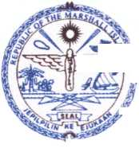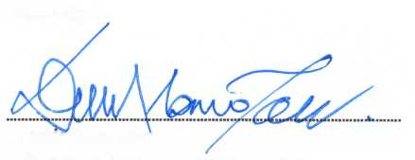

August 20, 2019

REPUBLIC OF THE MARSHALL ISLANDS  
Ministry of Natural Resources and Commerce  
Post Office Box 1727  
Majuro, Marshall Islands 96960

To the attention of the GAFSP Coordination Unit,

*Subject: Submission of the Multi-Country Proposal for the Small Islands Food and Water Project (SIFWaP)*

I write to you in reference to the GAFSP Special Call for Proposal for Fragile and Conflict Affected Countries - Public Sector Window, of March 14, 2019.

I am pleased to submit to your attention the multi-countiy proposal for the Small Islands Food and Water Project (SIFWaP) to be implemented in the Republic of the Marshall Islands, the Federated States of Micronesia, Kiribati and Tuvalu.

In my capacity as the Minister responsible for Agriculture Development in the Marshall Islands, I hereby confirm that the Ministry of Natural Resources and Commerce of the Government of the Republic of the Marshall Islands:

* selects the International Fund for Agricultural Development (IFAD) as the Investment Supervising Entity and the Food and Agriculture Organization of the United Nations (FAO) as additional supervising entity for Technical Assistance; and
* authorizes IFAD to submit the attached proposal on behalf of the Ministry.

Sincerely,

Dennis Momotaro

Minister of Natural Resources and Commerce